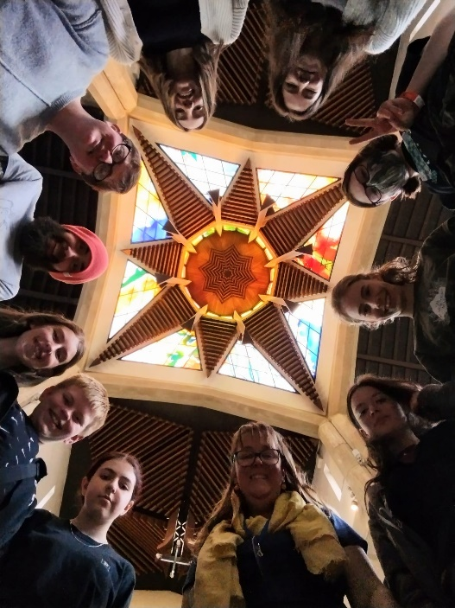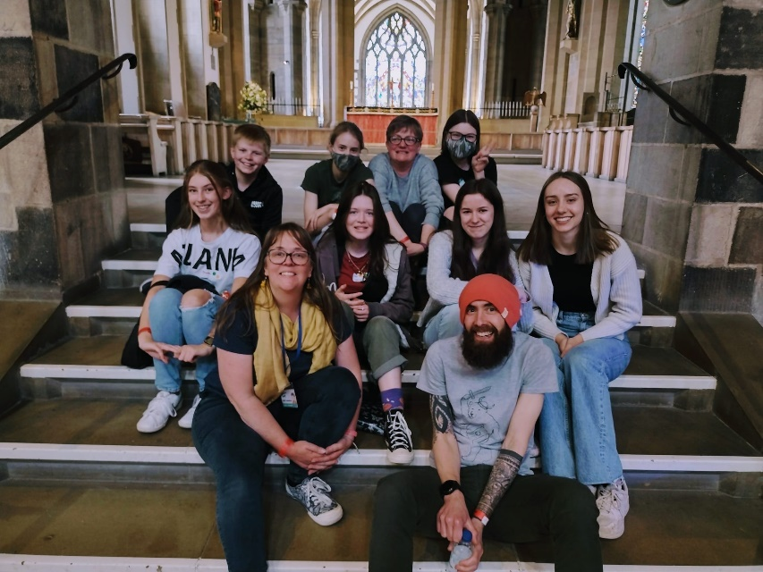

**All Change**

2022 has brought about many changes and developments for us. With so much having happened we have loads to tell you!

* Face to face meetings resumed!
* Kelly Gibbons joined us as our Schools and Youth worker (a terrific addition to the team)
* On Sundays we have looked at the gospel of Luke and learning healthy spiritual habits (praying, reading the bible, worship etc.) and practical ways of living out our faith. Split groups according to age.
* Tuesdays have been evenings of games, fun and occasional food! (Baking sugar cookies, making chocolates and eating chips!) We have made friendship bracelets, had a go at crochet, made giant bubbles, failed to learn how to juggle and played LOTS of dodgeball. Again, split age groups but with sometime in the middle as one group. We also spend time relaxing and talking.
* Both sessions have games, Throw Throw Burrito/Avocado, taco, cat, goat, cheese, pizza, spoons, and others. We had to teach Kelly how to play them!
* Breath deep was held at the new venue, Sheffield Cathedral, Bishop Sophie answered some important life questions (Obviously Marvel or DC?) We spent time worshiping, singing, and learning, as well as crafts, playing games, inflatables, on the Message Bus or relaxing before ending the day with praise.
* School had us back in to work with the young people
  + Transition work Y6
  + Unique course Y4

**Looking Forward**

This year we are excited to be able to take our young people on a residential in summer to Marrick Priory with others from the Methodist circuit. Some great activities are planned, zip lining, water sports as well as campfires and film nights.

**Prayers**

For our young people to have a restful, safe, and enjoyable summer.

For us to be blessed with new young people joining us in September

For the residential, that God will have his hand on us and that the leaders get enough sleep!

Thanks for reading

God Bless

Breath Deep 2022

Breath Deep 2022

Soulroots has continued to engage with young people throughout the Covid pandemic, Zoom became the new norm! Then, when allowed, outside for various activities (even in the rain!)

A huge thankyou to all the young people who persevered and carried on, we know how tedious and frustrating online meetings were for you all!

Importantly, this was able to happen with the hard work and dedication of Mell our Youth Worker and of course our amazing volunteers, Chris and Helen Muster.

Their passion and drive have been invaluable!

Thankyou!

Soulroots 2022

Contact us:

Mell 0738018759 / [mell@soulroots.org.uk](mailto:mel@soulroots.org.uk)

Kelly 07830183769 / [kelly@soulroots.org.uk](mailto:kelly@soulroots.org.uk)

07/2022